Salesiánská asociace Dona Boska, o. s.
Kobyliské nám. 1000/1, 182 00 Praha 8 – Kobylisy
tel. 283 029 229, email: rinaldi@sadba.org
IČO: 27006131
www.sadba.org
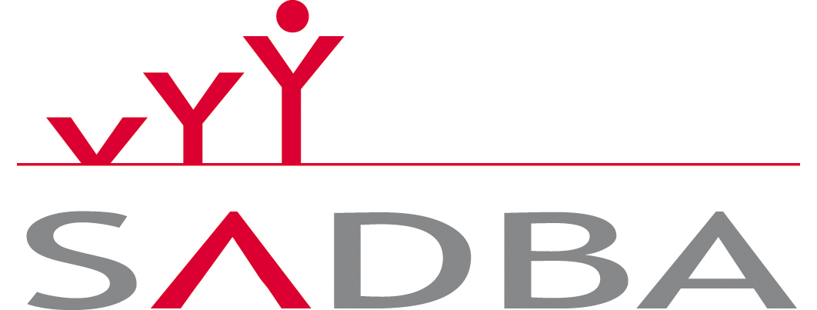
APPLICATION FORM iSEC– Inline Salesian English Camp
30th July to 11th August 2024

1. PERSONAL DETAILS
First Name: |  | Surname:
Age: |  | Address:
E-Mail address: |  | Mobile:
2. EDUCATION & PROFESSIONAL DEVELOPMENT
- What do you study? /Where do you work?
- Do you have any special trainings? (e.g. First Aid, Health & Safety, etc.)
3. PERSONAL EXPERIENCE/DEVELOPMENT
- How would you describe yourself?
- What do you think your key strengths are?
4. MOTIVATION
- Why would you like to come as a volunteer to iSEC?
5. EXPERIENCE WITH SALESIANS
- Do you have any experiences with Salesians or other youth organisation? If yes, please give details.
6. Health and special needs
- Do you have any disability or allergy? If yes, please give details.
- Requirements regarding food – allergies, vegetarianism etc
If you are completing this form electronically, by typing your name in the 'signature' section, your application will be treated as signed.
Signature: |  |  | Date:

